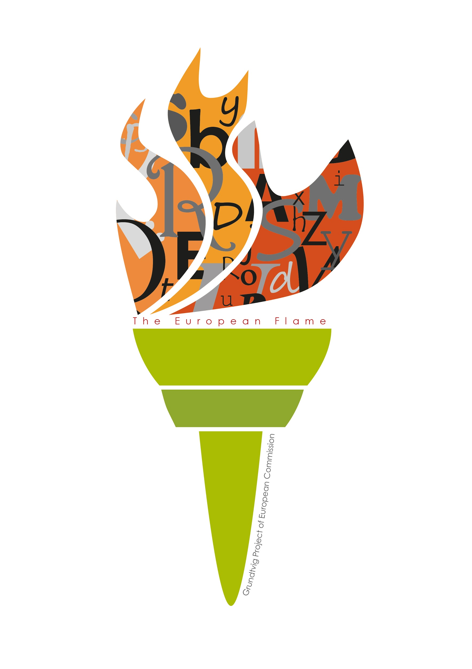
Short description of the tool or activity

What is it?

How does it work?

What is specific about the tool?

Are there advantages/disadvantages?

Source: where can the tool be found

Quality labels
If a tool or activity scores remarkably good (favorable) on a particular criterion, you put a cross in column number 2, which is green.If a tool or activity scores remarkably poor (unfavorable) on a particular criterion, you put a cross in column 0, which is red. If the result tend to be intermediate, you can choose column number 1 (orange).
Please provide a short remark if you think it is necessary to point out a particular characteristic of the tool.
Label | General definition | Examples | 0 | 1 | 2
Purpose | The extent to which the tool meets the requirements of the selected purpose(s) | - Meet/choose new words  - Discover the meaning/form ( clear meaning, pronunciation, spelling)  - Integrate (new) words  - Consolidate words  - Master/use words |  | X
 | Remark:
Ease of use | The extent to which the tool or activity is workable | Cognitive complexity, interface, layout, instructions, skills needed, language, clarity of task, ease of access (mobility, startup time, materials needed)
 | Remark:
Investment | The investment you need to make | Cost, time investment, effort (setup: download, software, materials, presence of ready-made exercises, randomization..)
 | Remark:
Outcome | The extent to which the tool has a good outcome | Number of words learned or practised, perceived intensity of learning (eg levels of Bloom: recognition, retention, analysis, application...), receptive vs productive
 | Remark:
Support | How much support do you get when you learn | Access to support, pronunciation available, connection to platform /course, feedback and evaluation, demonstration, visual support
 | Remark:
Methodology | Is the methodology sound | Variety in exercises, use of context, activation of the learner, possibility to choose own method, use of repetition, loop learning
 | Remark:
Quality of language | Are the exercises reliable wrt language | Spelling, correctness of translation, accurate language level
 | Remark:
Perspective | Information on your progression (micro/mesolevel) | Information on progress made, visualization of results, benchmarking
 | Remark:

